Text Categorization
Assignment 3

By Low Choon Meng (U053736R)
Chua Kien Chuan (U087140B)
Xu Wei Jie (U057020R)

Abstract

For this assignment, we are to implement a system to perform text categorization and of at least 2 categorization methods: kNN (k Nearest Neighbour) and Decision Tree.

Implementation

Design & implementation of algorithm
Since there are two different methods to be applied in this module, our algorithm is split into two parts: Decision Tree and K Nearest Neighbour. These two methods are implemented independently into two separate programs running on separate GUIs.

Modeling the problem

Heuristics used.

Description of algorithm and methods
Decision Tree
- Decision Tree Model
- Tree Traversal
K Nearest Neighbour
- Term Selection
- Similarity
- Neighbour Distance Calculations
For generating the decision tree, there are many algorithms available. W-J48 produces a C4.5 type of tree.

Efficiency of the program

Problems encountered
Stemmer.jar problems
Stoplist problems
Decision Tree problems

Testing
For the testing of the Decision Tree, we generated a performance vector using RapidMiner. The performance vector consists of all the files from the testing_corpus folder attached to the assignment and is tested on the decision tree. The results are as shown is the figure below:
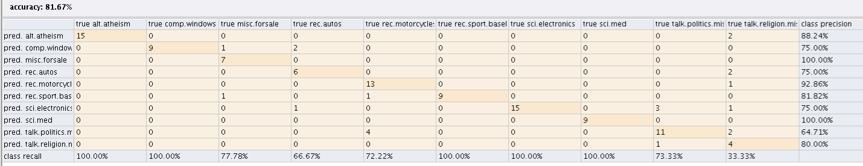
Total accuracy of the decision tree is 81.47% tested with the files in the testing_corpus folder. This is using the W-REP method for generation of the tree.

Future Enhancements

Conclusion

